Who will be setting up our hacking app to do this you just need to install Kali Linux in your vmware.

You can download it from the official website

vmware.com

below try workstation 17 player from Windows click download now

After the download is complete just install it

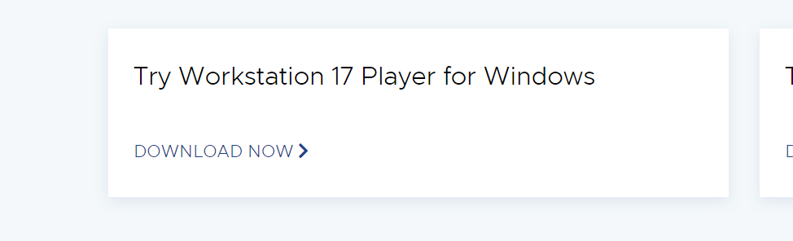

Will need to download Kali Linux. We will be using the pay for figure file.

For this just search on Google kali linux VMware download

Open the first official link

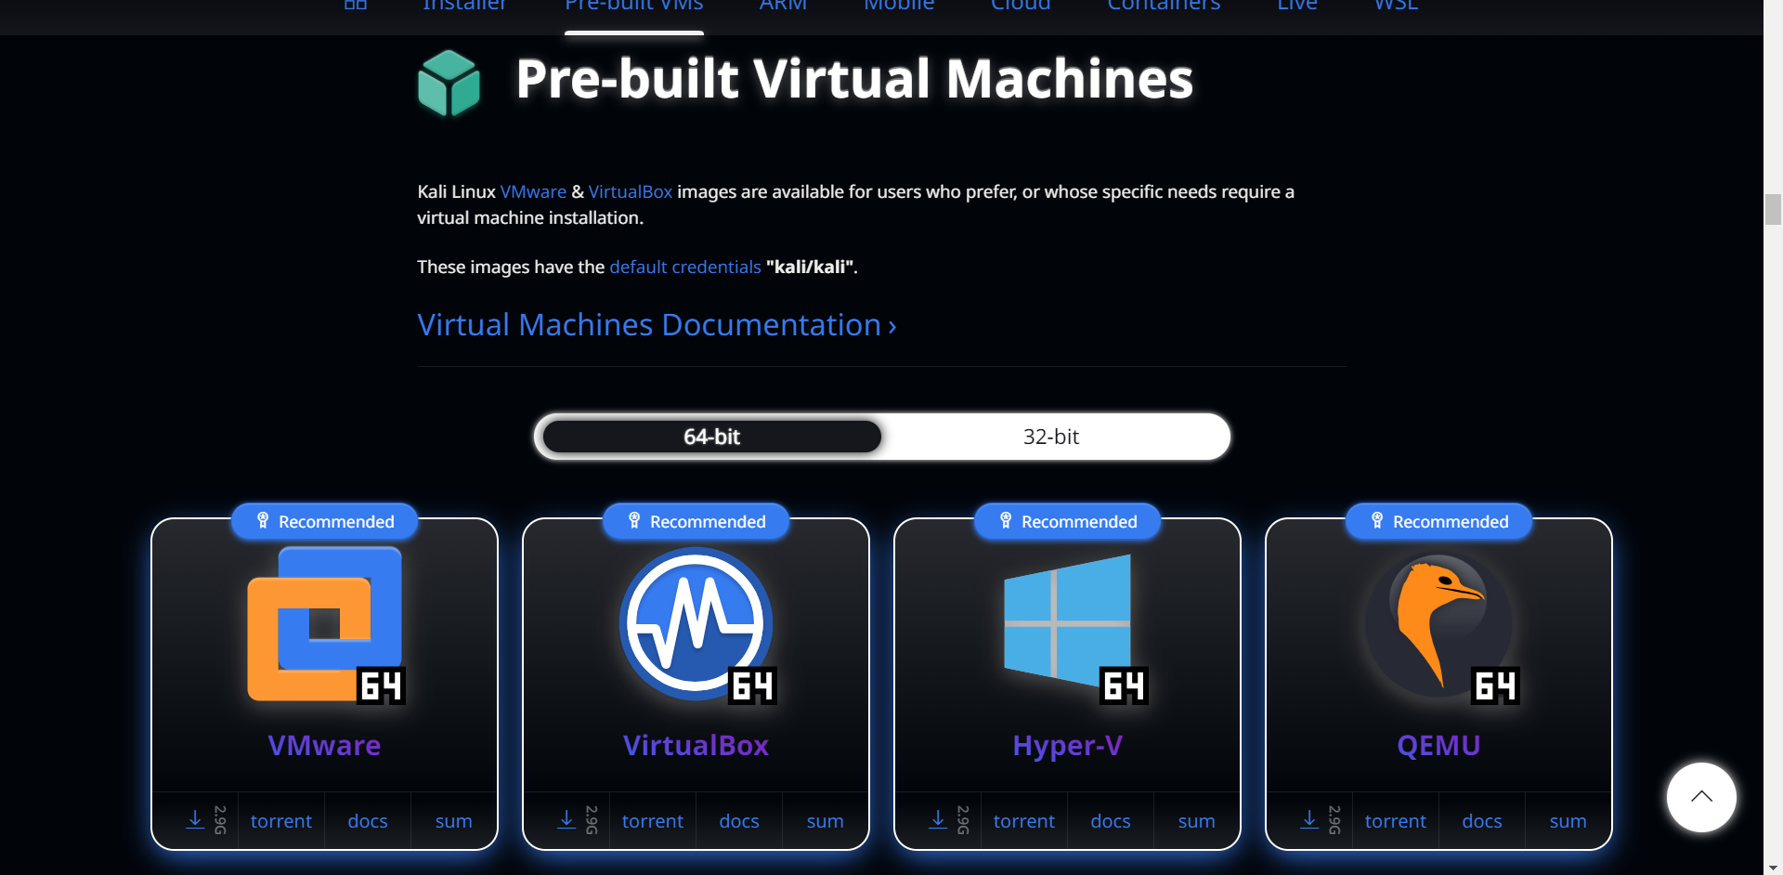

Select vmware and download the file.

After they download is complete just click on it and use vmware to open it. Give it sometime after sometime your kali linux will be installed.